Pratik: Good morning everyone present here. Today I and few of my colleague would like to share some interesting and useful information with you all. So I require some of your time. So we are introducing to our presentation and topic of our presentation is L&T or LTI which I also known as Larsen & Toubro Limited. But after certain time span the L&T Company was also known as LTI (Larsen and Toubro InfoTech) with the tag line as “Lets solve”

The company is well known for its work and goodwill in industrial world, first of all I would like to focus your attention on journey of company from start up to its present base. In initial decades ago the FOUNDER of L&T group MR. SANJAY JOLONA took high efforts and spent their overall time for company’s growth and development, as we see the result now a day’s company is one of the reputed company in the IT sector.

The startup to the company was given on 23rd Dec 1996 by MR.JOLONA and some of this supporters with the aim to give best services in various different sector like construction manifracting IT sector and many more.

Hello everyone now I am going to describe briefly about LTI global presence

Prajakta:

Where as in the IT sector the main focus on the Digital and automation solutions and IT Consulting.

: The company has provided various job opportunities to people in various different cities as their main headquarters is located at BALLARD ESTATE in Andrei East and sub quarters at various cities in other countries like Canada Mexico United States in North America England Germany n many more in Europe and Mumbai Pune Bangalore Chennai Hyderabad and many more in India.

LTI they have their branches in more than 20+ countries which is a very big thing. Other than this LTI also gives there employees an opportunities to work in abroad with new technology. On the other hand LTI enables every employee to interact with their clients to improve the effectiveness of the client’s business technology and their shareholders and that is the reason the LTI shares are most probably high in share market. Which is always beneficial to the company and their clients.

Omkar : Due to this all hard work and consistency of the company

The important purpose or main view of the company was to give render services to people in IT SECTOR

and make the work easy to employee working in it.

I would like to share with you that L&T Company was ranked 6th largest company in India among the IT sector in year 2016. And in year 2017 it was in top 15 IT services companies globally. LTI also won CMO Asia Award In two categories among which first was Brand Excellence in IT and second was ITES 2019 and marketing campaign of year.

On the other hand I would like to inform the revenue of this company is 11204 crocs in Indian currency.

The company servers the job to around about 30000+ employees which shows the strength of the company.

The company focuses mainly in all field of IT like

1) Cloud which consist of IAAS SAAS and Native of Cloud

2) Cloud Infrastructure services which mainly consist of Block chain, next gen Workplace, Design studio, OCM

3) Agile

4) Assurance and quality engineering

5) Application development and its maintains

6) System Integration

7) Big data analytics

Pajakta:

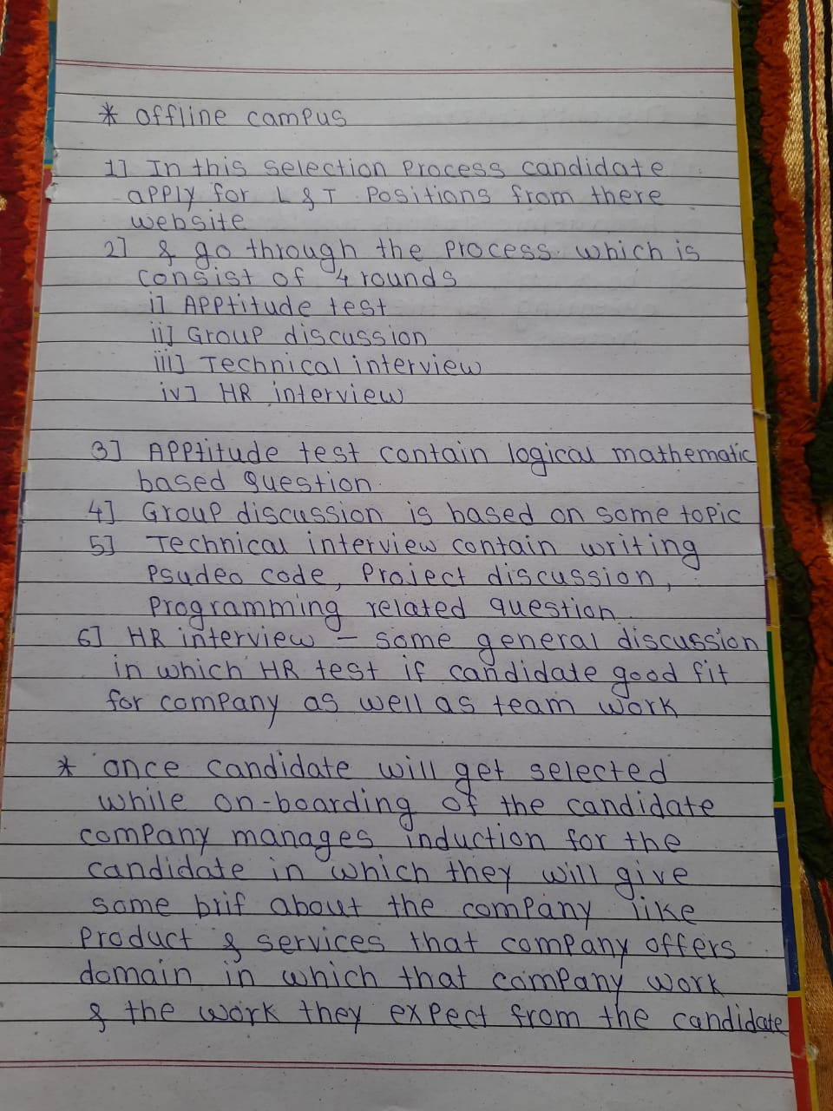 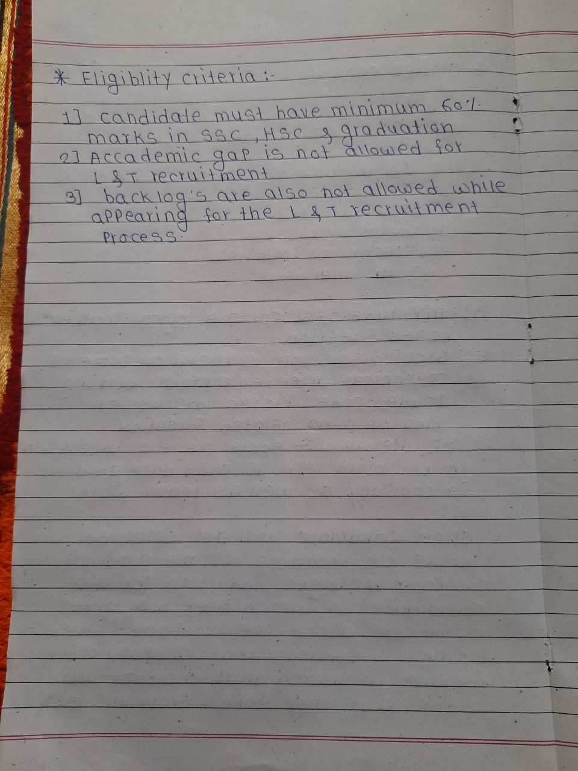

Nitin:

As we know that the LTI company is much much reputed in IT sector but as a coin has two sides same as each thing have a contrary part too lets have a short view of that too. In the year 2016 there was a big contravercy for LTI management for revoking offer letters of few recruits after waiting for the period of 18 months which was a big thing for recruits on the other hand in subquaters of Chennai due to disprut in IT corridor the employees made a protest against company’s management. But later on it was solved and a strict action was taken against management.

Overall the LTI company is a wellknown Brand for there improvement and serivces they provide in each field of IT sector .The overall work space or the work culture in the company is much good due to their good conversation ability among each other and happy and enjoyable enviornment in the company.

Thank you for giving us your valueable time hope you like our presentation. If any queries we will happy to help you out.